|  |  |  |  |  |  |  |
| --- | --- | --- | --- | --- | --- | --- |
| Name of Examination | | **Quiz-** **Winter 2020-21 Semester**, (June 2021) | | | | |
| **Slot: G1** | | Course Mode: Regular (Online) | | | **Class Number (s):** VL2020210504635  **M.Tech** | |
| Course Code: | CSI2003 | | Course Title: | **Advanced Algorithms** | | |
| Emp. No.: | 15883 | | Faculty Name: | Kannan A | | School:SCOPE |
| Contact No.: | 9444231185 | | Email: | kannan.a@vit.ac.in | | |

Answer all the Questions.

Marks: 10 x 1 = 10 Time: 30 Minutes

Choose the correct option from the following

1. Consider the following C program implementing the Euclidean Algorithm

|  |
| --- |
| int main()  {     int x, y, m, n;     scanf ("%d %d", &x, &y);    /* x > 0 and y > 0 */     m = x; n = y;     while (m != n)     {        If (m > n)           m = m - n;        else           n = n - m;     }     printf("%d", n);  }  If x=4 and y = 6, the value of n after the execution of this program and its time complexity are:  Options:   1. 1 , O(n) 2. 2, O(n) 3. 1, O(log n) 4. 2, O(log n) 5. The optimal solution for the 0/1 knapsack problem making use of dynamic programming approach, by considering the number of items n = 4, the knapsack capacity w = 9 kg, (w1, w2, w3, w4) = (2, 3, 4, 5) and (b1, b2, b3, b4) = (3, 4, 5, 8) can be obtained by taking   A. w1, w2 and w3  B. w1, w2 and w4  C. w2 and w3  D. w3 and w4   1. The height of the tree required to solve the Missionaries and Cannibals problem given below using backtracking algorithm technique is:   Three Missionaries and three Cannibals are standing at the left bank of a river. They have a boat with a capacity of two which can be sailed by both missionaries and cannibals. The important constraint of this problem is that at any point of time, the number of Cannibals must not outnumber the number of missionaries. Provide a solution to take them from the left bank to the right of the river using Depth First Search Algorithm.   1. 9 2. 10 3. 11 4. 12 5. The maximum flow that can reach the destination T from the source S that is found using Ford-Fulkerson algorithm in the following graph is 6. 6 7. 7 8. 5 9. 4   Flow network |

1. Which of the following numbers is a prime number? You can use primality testing.
2. 8191
3. 8193
4. 8195
5. 8197
6. Which of the following can be referred to as applications of Randomized algorithm?  
   a) Merge Sort Algorithm

b) Quicksort Algorithm

c) Linear Search Algorithm

d) Binary Search Algorithm

1. The minimum number of colours required for colouring the vertices of the following graph in such a way that no two adjacent vertices are coloured using the same colour is

A. 5

B. 4

C. 3

D. 2

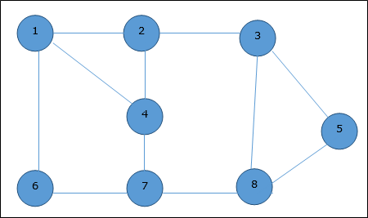

1. The vertex cover for the following graph consists of
2. 5 nodes
3. 4 nodes
4. 2 nodes
5. 3 nodes

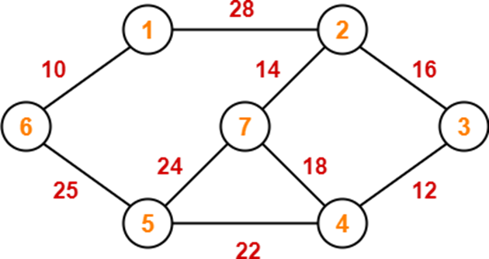

1. Suppose, the following items are to be packed using any one of the bin packing algorithm that requires the minimum number of bins. Which algorithm is more suitable for this set of itmes?
2. Next Fit
3. First Fit
4. Best Fit
5. Best fit Decreasing

Items = (0.2, 0.3, 0.5, 0.4, 0.7, 0.1, 0.6, 0.8, 0.3)

10. The maximum number of cliques that are in the following graph is:

1. 6
2. 5
3. 4
4. 3

